PASTORAL POSITION OPENING
FIRST BAPTIST CHURCH CARVER

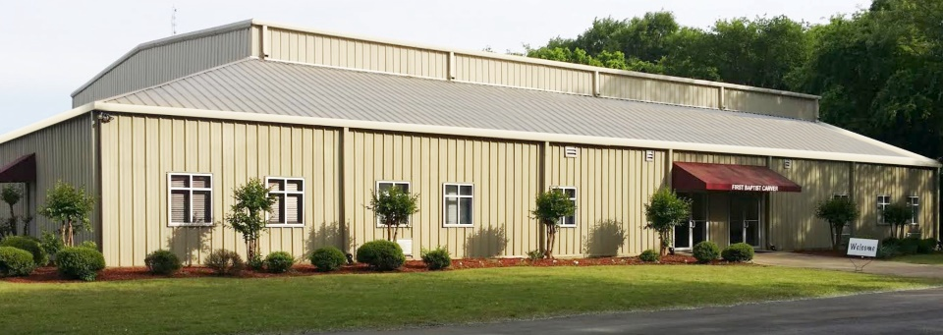

First Baptist Church Carver, 1300 23rd Street North, Bessemer, Alabama is seeking a full-time pastor, called by God who will be the spiritual leader of the congregation. The qualified candidate is responsible for providing Christian leadership in all areas of the church and to engage in pastoral care for the congregation.

Full-Time Pastor
Opening Date: April 27, 2020
Closing Date: June 8, 2020

Primary Qualifications and Duties

Note: The following provides an overview of the expectation. The full duties include but are not limited to those listed below:

- Must Plan and conduct worship services, develop sermons and leads in the observance of the ordinances.
- Must be a licensed, ordained Baptist minister.
- Must have proof of Theology Studies and Training or completed a degree from an accredited college or university in Divinity.
- Background must include effectively overseeing church administration.
- Preaching Sermons and teaching in Bible Study, Sunday School and other teaching opportunities as appropriate

Please see application checklist below to be considered:

***Please mail Completed Application, a Picture and Resume via USPS to***
First Baptist Church Carver
Attention: Pastoral Search Committee Chairperson
P.O. Box 1734
Bessemer, AL 35021

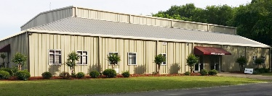
First Baptist Church Carver
APPLICATION FOR EMPLOYMENT

Please type all information requested.

GENERAL INFORMATION
Name (Last) | (First) | (MI) | Home Telephone  ( )  Cell: ( )
Address (Mailing) | (City) | (State) | (Zip)
E-Mail Address | Are you legally entitled to work in the U.S.?  ☐ Yes ☐ No | Birth Date (MM/DD/YYYY
Current Employment | Position |  | Business Telephone  ( )
Address (Mailing) | (City) | (State) | (Zip)
Marital Status  (Married/Divorced/Separated/Single  Widow) | If Married, Spouse Name
Children Name and Ages:

Are you Ordained?  ☐Yes ☐No | Have you been baptized by immersion?  ☐Yes ☐ No
Date and place of Ordination: | Denomination: | City and State

POSITION
Position Desired? | Will Accept:  Full-time ☐  Part-Time ☐
Have you been convicted of a felony?

☐ Yes ☐ No

If yes, explain:

E-Mail Address | Are you legally entitled to work in the U.S.?  ☐Yes ☐No

EDUCATIONAL BACKGROUND

Type of School | Name of School | Location  (Complete Mailing  Address) | No. of Years  Completed | Major & Degree
College/University

Vocational or
Technical School

Graduate School

Other

Must provide proof of Theology Studies and Training or completed a degree from an accredited college or university in Divinity. (Submit Proof with Application)

Veteran Information | Branch of Service | Date of Entry | Date of Discharge | No. of years

WORK EXPERIENCE

Name of Employer: | Name of last Supervisor: | From: To:
Address: | Telephone No. | Job Title
Reason for Leaving: | May we Contact this employer for a reference?  ☐Yes ☐ No | Hours Per Week?

Name of Employer: | Name of last Supervisor: | From: To:
Address: | Telephone No. | Job Title
Reason for Leaving: | May we Contact this employer for a reference?  ☐Yes ☐No | Hours Per Week?

Name of Employer: | Name of last Supervisor: | From: To:
Address: | Telephone No. | Job Title
Reason for Leaving: | May we Contact this employer for a reference?  ☐Yes ☐No | Hours Per Week?

Please briefly describe your general background: summarize your ministry strengths and challenges; ministry preferences and vision; and your special interests in ministry.

Are you presently being investigated or under a procedure to consider your discharge for misconduct by your present employer? _____ Yes _____ No

Has any employer ever subjected you to disciplinary action, suspended, terminated or asked you to leave a job or volunteer position on the grounds of any unlawful sexual behavior, or violation of an employer’s sexual misconduct or harassment policy? ____ Yes ____ No

I understand that I am subject to a background check that includes, driver’s license check, police record and educational and/or specialized training credentials listed on resume.
___________
Initials

Please provide all applicable information:

Personal and Church website:

Personal and Church Facebook pages:

All other social media tags (pages):

PROFESSIONAL REFERENCE

Do not list family members or relatives for references.

Give three references who are qualified to speak of your spiritual experience and Christian service. List your current pastor first.

Name and Complete Address: | Telephone Number: | Position:

AGREEMENT (PLEASE READ CAREFULLY BEFORE SIGNING

I certify that all the information in this application is accurate and complete to the best of my knowledge and I have not knowingly withheld any information that might adversely affect my chances for employment. I understand that misleading or false statements will constitute sufficient cause for refusal of hire or termination of my employment.
______
Initials
I understand that neither the acceptance of this application nor the subsequent entry into any type of employment relationship with First Baptist Church Carver creates an actual Or implied contract of employment. I understand that if I accept employment First Baptist Church Carver, it will be on an at-will basis. This means that either First Baptist Church Carver or I have the right to terminate the employment relationship at any time, for any reason, with or without cause.
______
Initials

Signature of applicant _____________________________________ Date ________________

